Why Can't I Use Version Control?

为什么我不能使用版本管理？

**Symptoms**

* My Version Control option is *greyed* out.
* 我的版本管理选项是灰色的
* I am trying to set up version control integration in Unity. In the Editor, if I go to ***Window - Version Control***and can see this option is not available:
* 我试图在Unity中设置版本控制集成。 在编辑器中，菜单***Window - Version Control***可以看到此选项不可用：

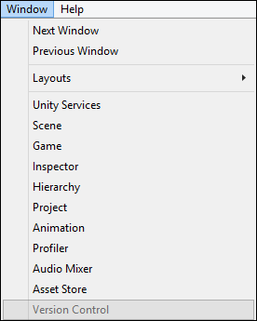

**Cause**

You will need to be using a Pro license with Team License features to use Version Control.

您需要使用具有团队许可证的Pro版本才可以使用版本管理

All Unity 5.x licenses come with Team License as standard, though older licenses required an add-on. If you have a 4.x or 3.x license, you may not have the add-on.

所有Unity5.x的许可证都以拥有团队许可证为标准，旧的许可证则需要一个附件。如果您是4.x或者3.x的许可证，那你可能没有没有附件。

**Resolution**

You must have a Unity Professional License with a Team License attached to use Version Control Integration features.

您必须拥有一个附有团队许可证的Unity专业版许可证才能使用版本控制集成功能。

The Team License is included when you purchase a Unity 5 Professional License or Unity Professional Subscription.

购买Unity5专业版许可证或者订阅Unity5专业版时，Team License会包含在内

If you use the Unity 5 Editor, you will have access to the Team License.

如果您使用Unity5编辑器时，您可以访问团队许可证

If you are using the Unity 4 or 3 Editor, even if you have a Unity 5 Professional license, it will not give you access to the Team License function as it was a separate add-on feature in Unity 4.x

如果您使用Unity4或Unity3编辑器时，虽然您有Unity5专业许可证，它将不能给你访问团队许可证的功能，在Unity4.x中使用插件将可以访问。

You will also need to have the Asset Server setup. You can do this via the [Setup Guide](http://unity3d.com/unity/team-license).

您还将需要设置Asset Server。您可以通过设置指南设置Asset Server。

To enable Version Control Integration for Unity 4, you will need to speak with sales by submitting your inquiry for a team license to our sales team via this [link](http://unity3d.com/company/sales?type=sales).

要开启Unity4的版本控制，您需要通过此链接询问我们的销售团队并提交您的团队许可证  
  
Your local sales adviser will be able to help you so set this up.

您当地的销售顾问能帮助您来设置。

**More Information**

Team license is slowly being replaced with [Unity Collaborate](https://unity3d.com/services/collaborate).

Unity许可证正在逐渐被[Unity Collaborate](https://unity3d.com/services/collaborate)取代。

See this document for a manual on setting up your [Version Control Integration](http://docs.unity3d.com/Manual/Versioncontrolintegration.html)

有关设置版本集成控制的手册，请参阅本文档。